1. Catalogue management
   1. Insert catalogue

Step 1: Click “Quản lý sách thông tin” menu

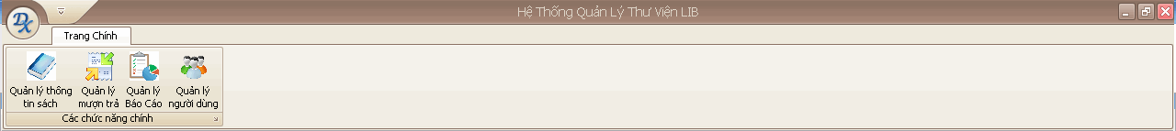

Step 2: Choose “Thêm sách mới” button

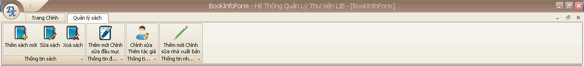

Step 3: Enter required fields.

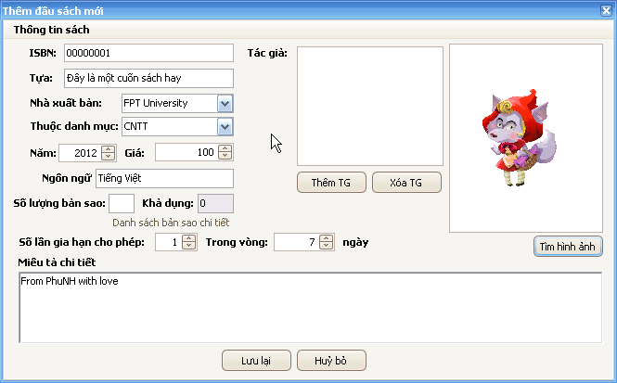

If you enter a number to “Số lượng bản sao” textbox so the system will automatic generate barcode for this number of books to the database (default is 0)

Choose author for the book by click “Thêm TG” button. Then a new form will appear. And you choose the appropriate author and click “Thêm TG” then the information of the author will be included in the catalogue’s information.

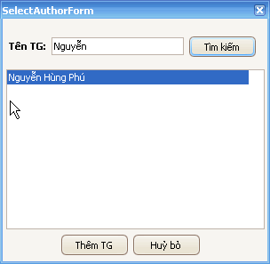

If you want to remove the author from the list author of book, click the author’s name and then press the “Xóa TG” button.

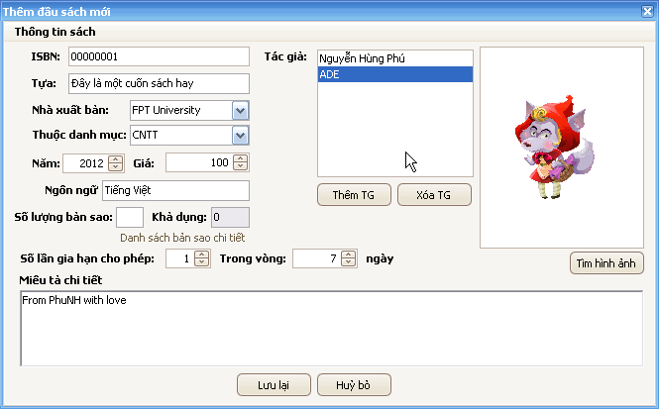

If you want to add a picture for the catalogue, click “Tìm hình ảnh” button then choose the appropriate picture and click “Open”

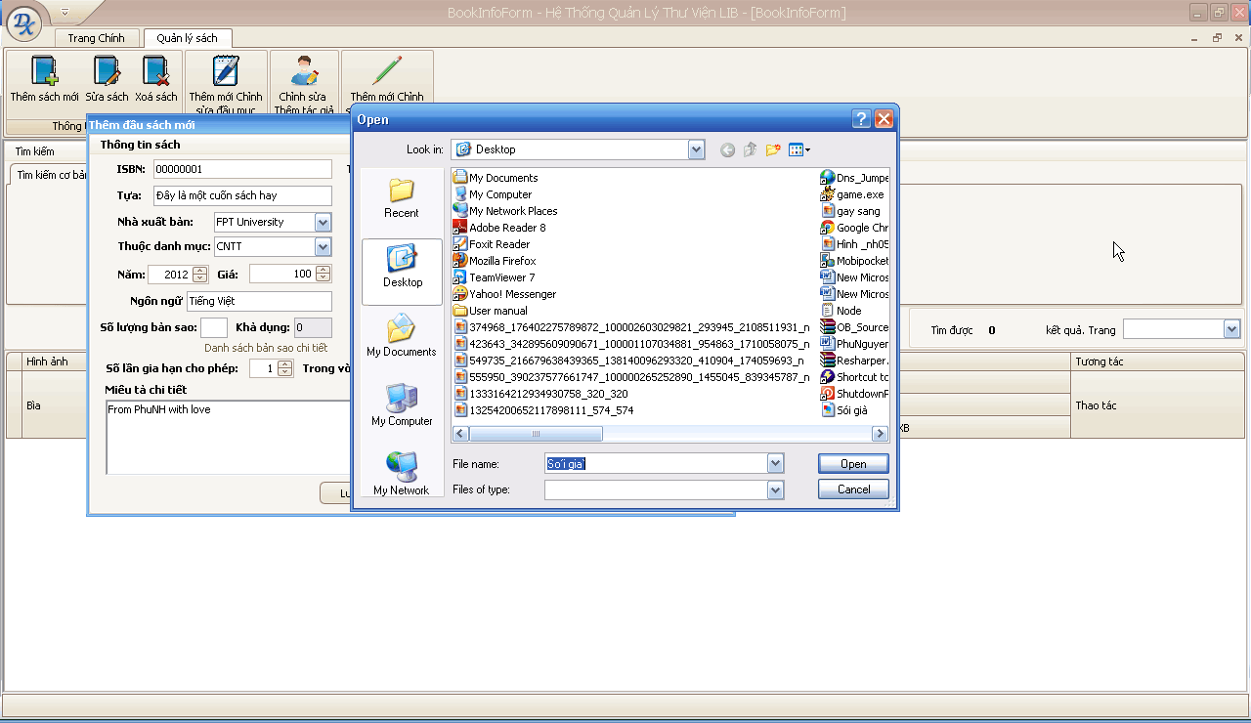

Step 4: After finished to fill in the catalogue’s information, click “Lưu lại” button

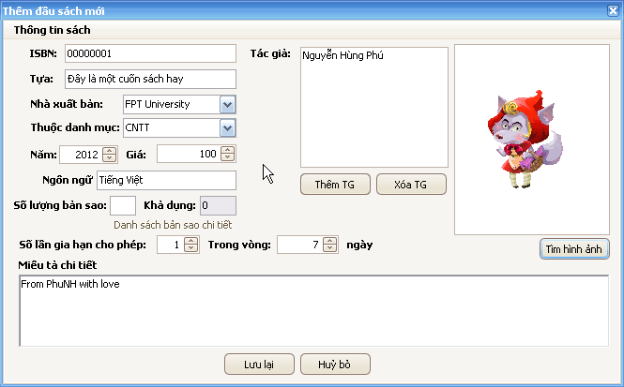

Then the catalogue will be inserted to the database

* 1. Edit a catalogue’s information

Step 1: Choose the catalogue which you want to edit then double click to it or you can also click to the button “…” in the right side of the catalogue list’s grid

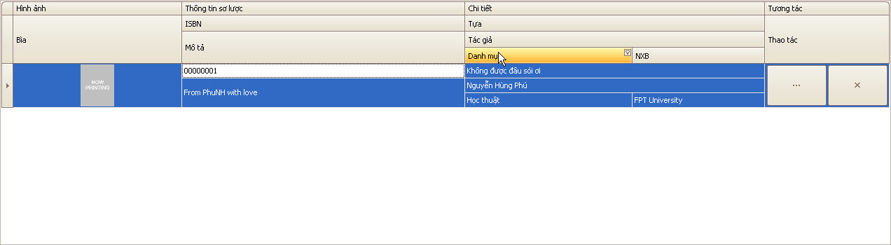

Step 2: Edit the fields which you want to edit

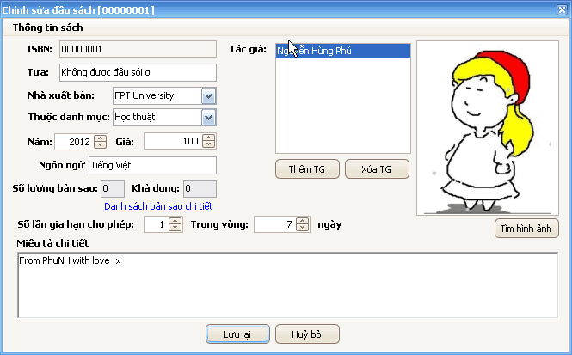

Step 3: Click “Lưu lại” button



Step 4: Click “Yes” button

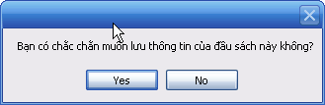

Step 5: Click “OK” button

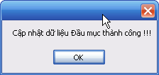

* 1. Delete a catalogue

Step 1: Choose the catalogue which you want to delete by click to the button “x” in the right side of the catalogue list’s grid

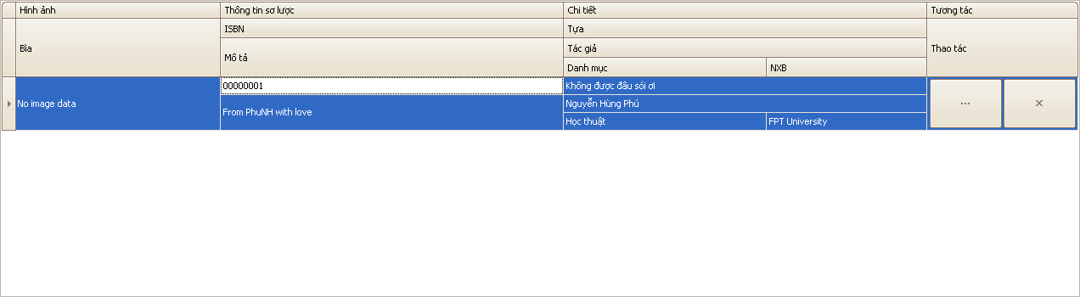

Step 2: Click “Yes” button

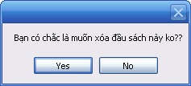

1. Author management
   1. Insert an author

Step 1: On the main form click on “Quản lý thông tin sách” button

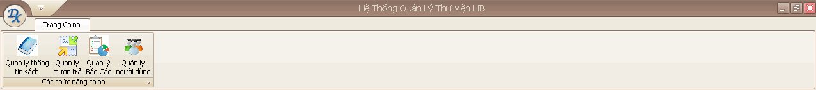

Step 2: Click “Chỉnh sửa thêm tác giả” button

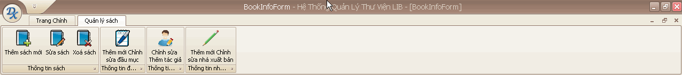

Step 3: Click on “Thêm tác giả mới” button

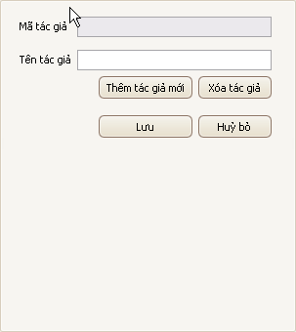

Step 4: Enter the author’s name

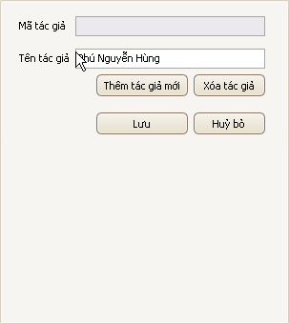

Step 5: Click “Lưu lại” button

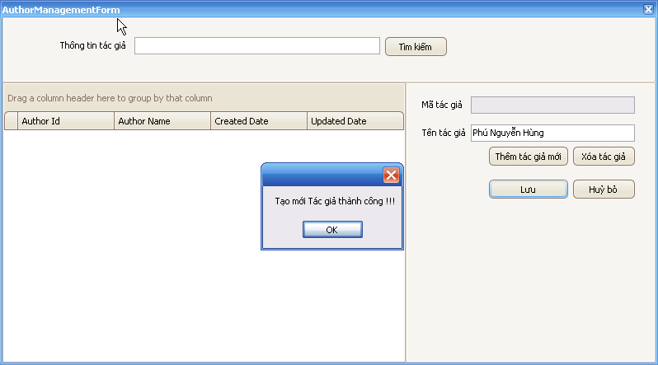

* 1. Edit an author’s information

Step 1: On the main form click on “Quản lý thông tin sách” button



Step 2: Click “Chỉnh sửa thêm tác giả” button



Step 3: Choose the author which you want to edit information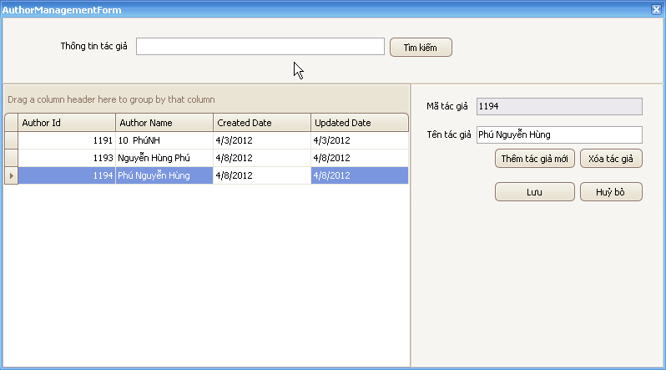

Step 4: Edit the author’s name

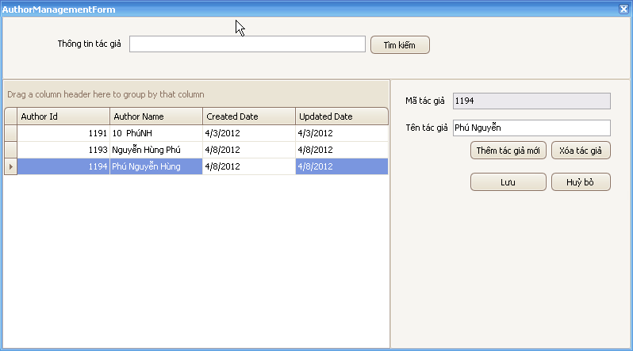

Step 5: Click “Lưu” button

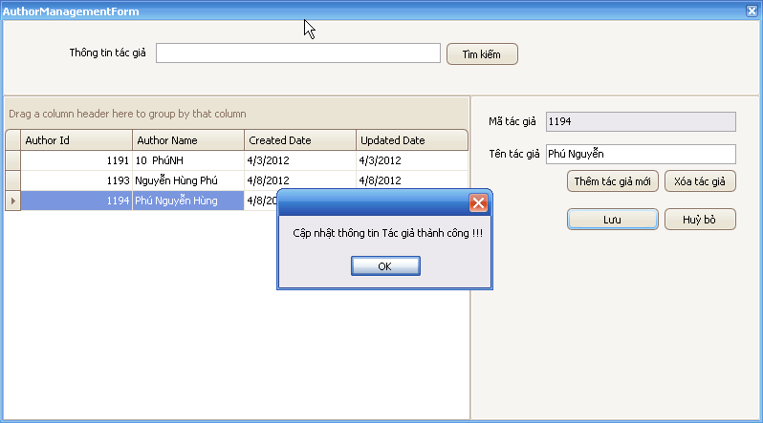

* 1. Delete an author

Step 1: On the main form click on “Quản lý thông tin sách” button



Step 2: Click “Chỉnh sửa thêm tác giả” button



Step 3: Choose the author which you want to delete

Step 4: Click “Xóa tác giả” button

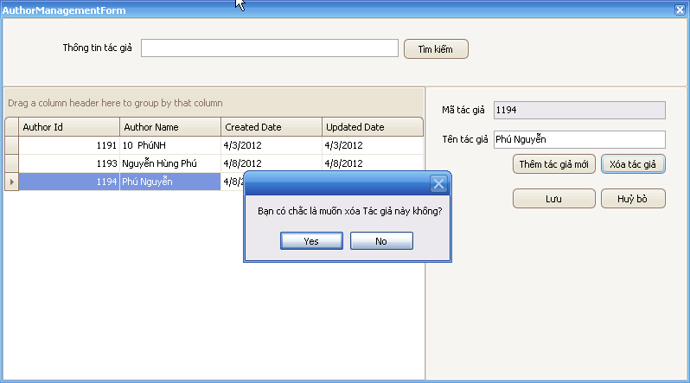

Step 5: Click “Yes” button

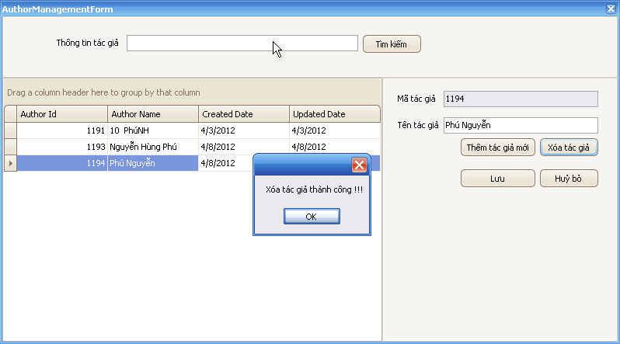

1. Publisher management
   1. Insert a publisher

Step 1: Click “Quản lý thông tin sách” button

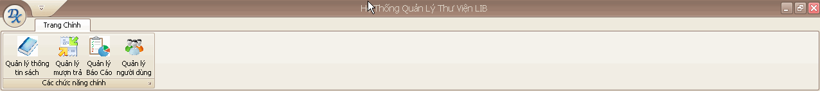

Step 2: Click “Thêm mới Chỉnh sửa nhà xuất bản” button

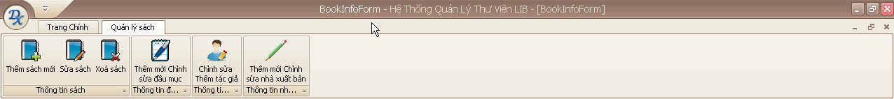

Step 3: Click “Thêm mới” button

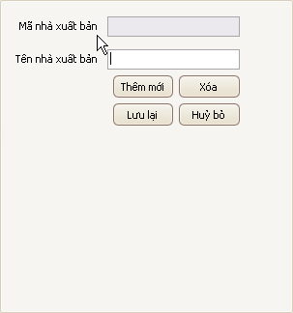

Step 4: Fill in the publisher’s name

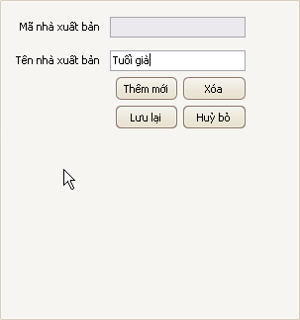

Step 5: Click “Lưu” button



Step 6: Click “OK” button

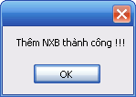

* 1. Edit a publisher’s information

Step 1: Click “Quản lý thông tin sách” button



Step 2: Click “Thêm mới Chỉnh sửa nhà xuất bản” button



Step 3: Choose the appropriate publisher

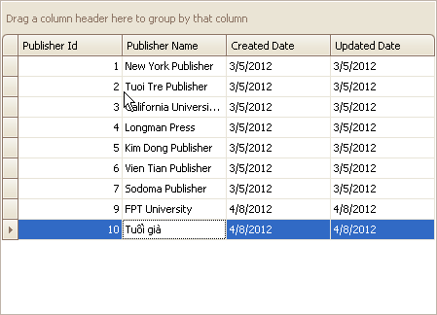

Step 4: Edit the publisher’s information

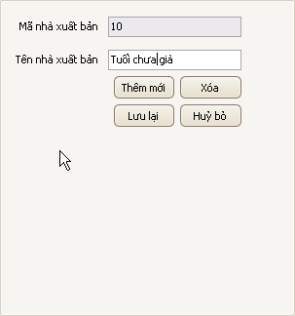

Step 5: Click “Lưu lại” button



Step 6: Click “OK”

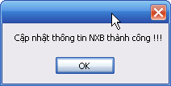

* 1. Delete a publisher

Step 1: Click “Quản lý thông tin sách” button



Step 2: Click “Thêm mới Chỉnh sửa nhà xuất bản” button



Step 3: Choose the appropriate publisher



Step 4: Click “Xóa” button

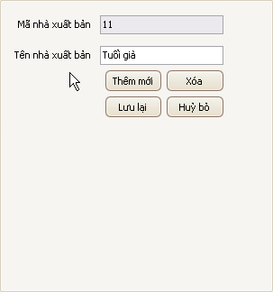

Step 5: Click “Yes” button

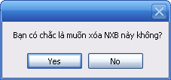

Step 6: Click “OK” button

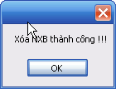

1. Category management
   1. Insert a category

Step 1: Click “Quản lý thông tin sách” button



Step 2: Click “Thêm mới Chỉnh sửa nhà xuất bản” button



Step 3: Click “Thêm mới” button

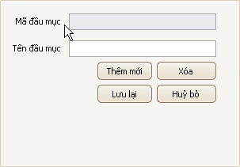

Step 4: Fill in the category’s information

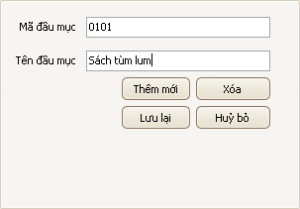

Step 5: Click “Lưu lại” button



Step 6: Click “OK” button

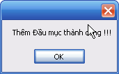

* 1. Edit a category’s information

Step 1: Click “Quản lý thông tin sách” button



Step 2: Click “Thêm mới Chỉnh sửa đầu mục” button



Step 3: Choose the appropriate category

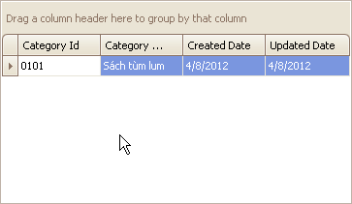

Step 4: Edit the category’s information

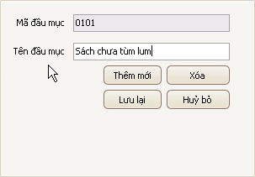

Step 5: Click “Lưu lại” button

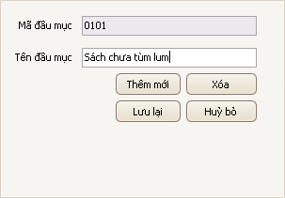

Step 6: Click “OK” button

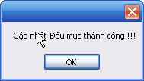

* 1. Delete a category

Step 1: Click “Quản lý thông tin sách” button



Step 2: Click “Thêm mới Chỉnh sửa đầu mục” button



Step 3: Choose the appropriate category



Step 4: Click “Xóa” button

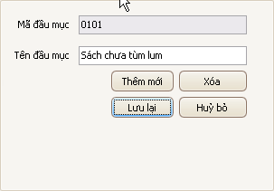

Step 5: Click “Yes” button

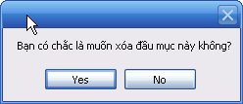

Step 6: Click “OK” button

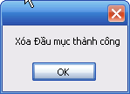

1. Copies management
   1. Insert copies

Step 1: Click “Quản lý sách thông tin” menu



Step 2: Choose the catalogue which you want to add copies then double click to it or you can also click to the button “…” in the right side of the catalogue list’s grid



Step 3: Click “Danh sách bản sao chi tiết” link

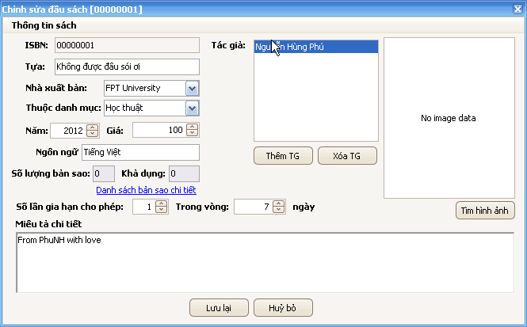

Step 4: Click “Thêm sách” button

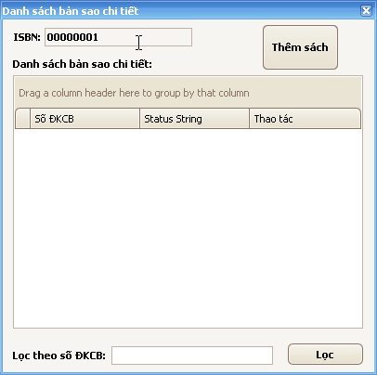

Step 5: Enter the number of copies you want to insert. Then click “Tạo ĐKCB” button. Then click “Đồng ý” button

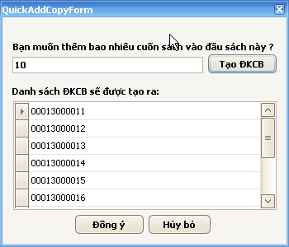

* 1. Delete copy

Step 1: Click “Quản lý sách thông tin” menu



Step 2: Choose the catalogue which you want to add copies then double click to it or you can also click to the button “…” in the right side of the catalogue list’s grid



Step 3: Click “Danh sách bản sao chi tiết” link



Step 4: Click the “X” button to delete copy with the specific barcode in the same line

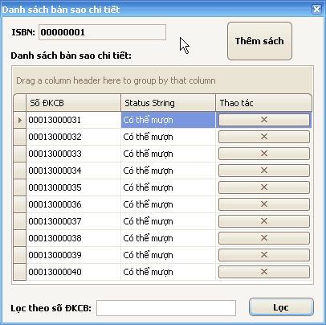

Step 5: Click “OK” button

